The First World War ____________________
Chapter 11 Period ______________
B.D.A. Mr. Conners

Battle Scene on Western Front During WWI
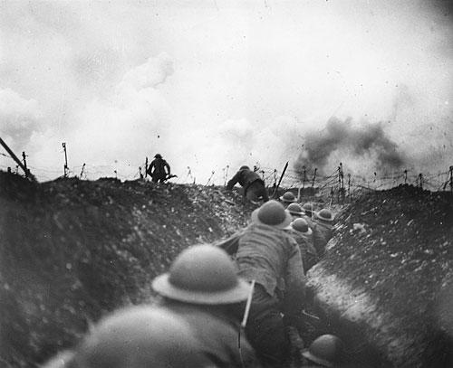
1. Study the photograph and create a list of adjectives to describe the battlefield.

2. What are the soldiers doing?

________________________________________________________________________________________________________________________________________________
3. Now, write a paragraph discussing how the battle scene in the photograph is similar to or different from the way war is waged today.
________________________________________________________________________________________________________________________________________________
________________________________________________________________________________________________________________________________________________
________________________________________________________________________________________________________________________________________________
The year is 1917. A bitter war is raging in Europe- a war that has been called a threat to civilization. At home many people are urging America to wake up and get involved, while others are calling for the country to isolate itself and avoid the fight.
Do you think America should enter the war?
- Is it right for America to intervene in foreign conflicts? ____________________________________________________________________________________________________________________________________
- When American lives are threatened, how should the government respond?
__________________________________________________________________________________________________________________________________
Should America go to war to make the world “safe for democracy?” ____________________________________________________________________________________________________________________________________

Read about the Causes of the Great War and answer the questions that follow.
Alliances

An alliance is an agreement made between two or more countries to give each other help if it is needed. When an alliance is signed, those countries become known as Allies.

A number of alliances had been signed by countries between the years 1879 and 1914. These were important because they meant that some countries had no option but to declare war if one of their allies. declared war first. (the table below reads clockwise from the top left picture)
1879  The Dual Alliance  Germany and Austria-Hungary made an alliance to protect themselves from Russia | 1881  Austro-Serbian Alliance  Austria-Hungary made an alliance with Serbia to stop Russia gaining control of Serbia | 1882  The Triple Alliance  Germany and Austria- Hungary made an alliance with Italy to stop Italy from taking sides with Russia
1914  Triple Entente (no separate peace)  Britain, Russia and France agreed not to sign for peace separately. |  | 1894  Franco-Russian Alliance  Russia formed an alliance with France to protect herself against Germany and Austria-Hungary
1907  Triple Entente  This was made between Russia, France and Britain to counter the increasing threat from Germany. | 1907  Anglo-Russian Entente  This was an agreement between Britain and Russia | 1904  Entente Cordiale  This was an agreement, but not a formal alliance, between France and Britain.

Imperialism
Imperialism is when a country takes over new lands or countries and makes them subject to their rule. By 1900 the British Empire extended over five continents and France had control of large areas of Africa. With the rise of industrialism countries needed new markets. The amount of lands 'owned' by Britain and France increased the rivalry with Germany who had entered the scramble to acquire colonies late and only had small areas of Africa. Note the contrast in the map below.
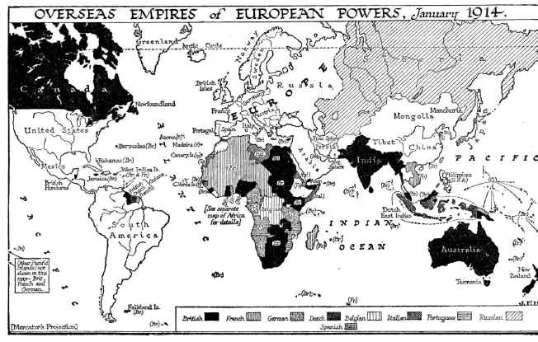

Militarism
Militarism means that the army and military forces are given a high profile by the government. The growing European divide had led to an arms race between the main countries. The armies of both France and Germany had more than doubled between 1870 and 1914 and there was fierce competition between Britain and Germany for mastery of the seas. The British had introduced the 'Dreadnought', an effective battleship, in 1906. The Germans soon followed suit introducing their own battleships. The German, Von Schlieffen also drew up a plan of action that involved attacking France through Belgium if Russia made an attack on Germany. The map below shows how the plan was to work.
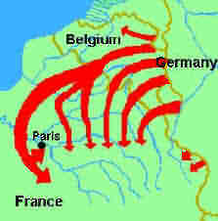

Nationalism
Nationalism means being a strong supporter of the rights and interests of one's country. The Congress of Vienna, held after Napoleon's exile to Elba, aimed to sort out problems in Europe. Delegates from Britain, Austria, Prussia and Russia (the winning allies) decided upon a new Europe that left both Germany and Italy as divided states. Strong nationalist elements led to the re-unification of Italy in 1861 and Germany in 1871. The settlement at the end of the Franco-Prussian war left France angry at the loss of Alsace-Lorraine to Germany and keen to regain their lost territory. Large areas of both Austria-Hungary and Serbia were home to differing nationalist groups, all of whom wanted freedom from the states in which they lived.

7. List the 4 long-term causes (M.A.I.N.) of the Great War.

____________________ ____________________

____________________ ____________________

In your own words, describe each of the long-term causes of the Great War.
- ________________________________________________________________________________________________________________________________
- ________________________________________________________________________________________________________________________________
- ________________________________________________________________________________________________________________________________
- ________________________________________________________________________________________________________________________________

Crises

Moroccan Crisis
In 1904 Morocco had been given to France by Britain, but the Moroccans wanted their independence. In 1905, Germany announced her support for Moroccan independence. War was narrowly avoided by a conference which allowed France to retain possession of Morocco. However, in 1911, the Germans were again protesting against French possession of Morocco. Britain supported France and Germany was persuaded to back down for part of French Congo.

Bosnian Crisis
In 1908, Austria-Hungary took over the former Turkish province of Bosnia. This angered Serbians who felt the province should be theirs. Serbia threatened Austria-Hungary with war, Russia, allied to Serbia, mobilised its forces. Germany, allied to Austria-Hungary mobilised its forces and prepared to threaten Russia. War was avoided when Russia backed down. There was, however, war in the Balkans between 1911 and 1912 when the Balkan states drove Turkey out of the area. The states then fought each other over which area should belong to which state. Austria-Hungary then intervened and forced Serbia to give up some of its acquisitions. Tension between Serbia and Austria-Hungary was high.
Read, An Assassination Leads to War on page 374 of your textbook. This assassination is some times referred to as the spark (immediate cause) that caused the war.
- Who was the Archduke Franz Ferdinand? __________________________________________________________________
- What was the Black Hand? __________________________________________________________________
- Who was Gavrilo Princip? __________________________________________________________________
- Why did Princip and Black Hand target Archduke Ferdinand? __________________________________________________________________
16. Summarize the long-term causes and the immediate circumstances that led to the Great War.
__________________________________________________________________
__________________________________________________________________
__________________________________________________________________
__________________________________________________________________
__________________________________________________________________
__________________________________________________________________
__________________________________________________________________
__________________________________________________________________
__________________________________________________________________
__________________________________________________________________

